TCN4211
Telecommunication Networks

Lab Number 2
Title Part 1 - Prototyping a Network / Part 2: Basic switch setup

Author Name: Anaisy Garcia PID: 5734454

Due Sep 20



Florida International University

OBJECTIVES:
This lab consisted of two separate parts one being network prototyping and the other being setting up a switch. For part one, the objective was to understand how to prototype a network using a switch and a simple topology. For part 2, the objective was to get familiar with setting up a Cisco switch and commands.
EQUIPMENT and COMPONENTS USED
For part 1 of this lab the equipment used was:
- Laptop
- Cisco Packet Tracer Program
  - Within the Cisco Program, the components used were two generic pcs and a switch connected with copper straight-through cables.

For part 2 of this lab the equipment used was:
- Laptop
- Cisco Packet Tracer Program
  - Within the Cisco Program, the components used were a router, a switch, and a laptop.

EXPERIMENTAL METHOD AND PROCEDURE
Part 1:
Procedure:
- Set up a network of two generic pcs and a Cisco 2950T switch.
- Connect PC0 to interface Fa0/1 on Switch0 with straight-through cables and PC1 to interface Fa0/2 on Switch0.
- Configure PC0’s IP address and subnet mask to 192.168.10.10 and 255.255.255.0.
- Configure PC1’s IP address and subnet mask to 192.168.10.11 and 255.255.255.0.
- Use ping with PC0 to ping PC1 to validate a successful connection.
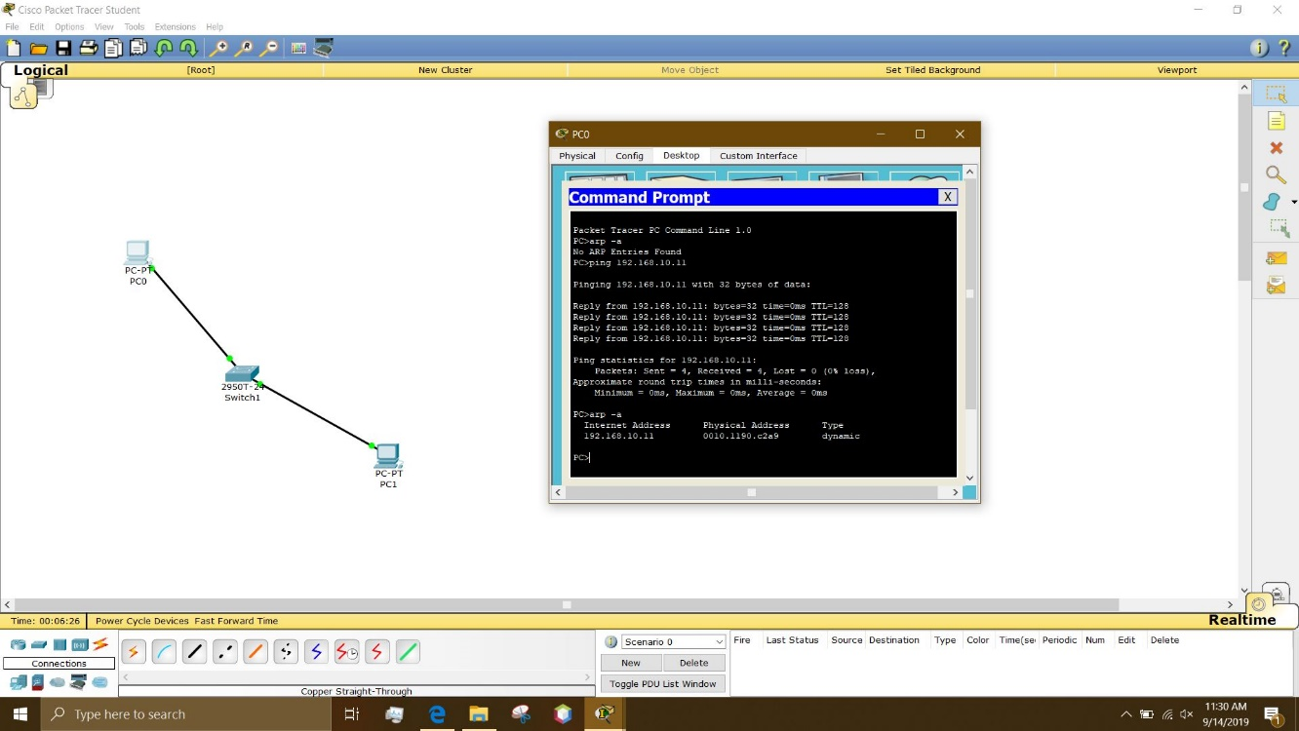
Part 2:
Procedure:
- Set up a network using a laptop, a switch, and a router.
- Connect the laptops RS232 port of the laptop to the console port of the switch using a console cable.
- Connect the switches FastEthernet0/1 port to the routers FastEthernet0/0 port using straight-through cable.
- Set up the switch using the terminal of the laptop. Change the name, add a password, add an IP address, and add a default gateway.
- Using the router, configure the terminal and switch. Set the interface, and IP address.
- Check LEDs on the router and switch to indicate healthy connection.
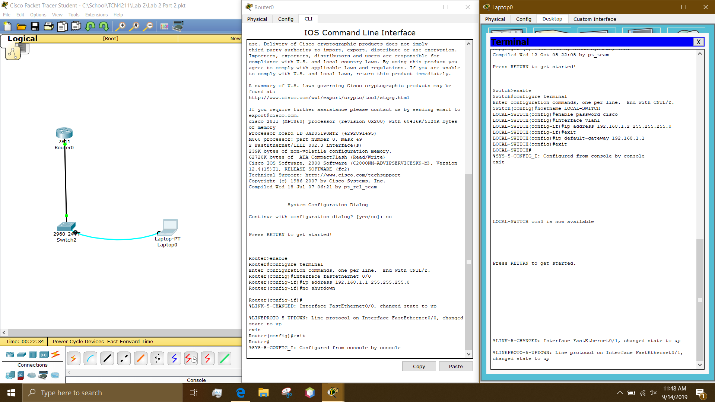

PROBLEMS/QUESTIONS
Part 1:
Question 1 – The switch’s LED indicators are amber right after the cables are connected. These LED indicators turn green after a few seconds, explain why?
The switches LED indicators are first amber due to not knowing the MAC address of the device yet. Once that connection is established the LED indicators will turn green to indicate a healthy connection.
Question 2 – What will happen if you used two cross-over cables to connect the computers to the switch? Why?
The cross-over cables with not allow the switch and computer LEDs to turn green indicating a healthy connection and when pinged the request gets times out. This is due to the wrong cable being used. The cross-over cables cause the transmitting terminal of the computer to connect to the transmitting terminal of the switch. This doesn’t allow for a transmit receive connection.
Questions 3 – What is the difference between ARP table entries on PC0 before pinging PC1 and after pinging? Explain why?
The ARP table before pinging PC1 was empty because the PC had yet to establish a connection to the other PC. Once PC0 is pinged, PC1’s MAC address showed up in the ARP table of PC0 showing a successful connection on that network.

Part 2:
Question 1 – Is it necessary to set an IP address for the switch? In other words, will it function without having an IP address?
A switch does not need an IP address because it can function as a pass through for computers with IP addresses.
Question 2 – What is the benefit of assigning an IP address to a switch?
Computers can all be connected to a switch without the need of an IP address but for administration purposes such as remote management.

RECOMMENDATIONS and CONCLUSIONS
In part one, its discovered that to prove a successful connection on a network with a switch a ping can be used. The ping allows for a successful ARP table to be filled with a MAC address of another computer on that same network. For ping to work the correct hardware and software must be used and configured. In part two, its discovered that a switch does not need an IP to function but to successfully connect to a router the terminal in a laptop and the settings on the router need to be configured. The laptop allows for such things as changing the name, setting a password, and setting an IP address and gateway of a switch.

